CSA1054 Software Engineering

LAB EXPERIMENTS (DAY 3)

NAME: P. VISHNU SAI

Reg number: 192210169

Draw And Validate Flowchart To Swap Two Characters

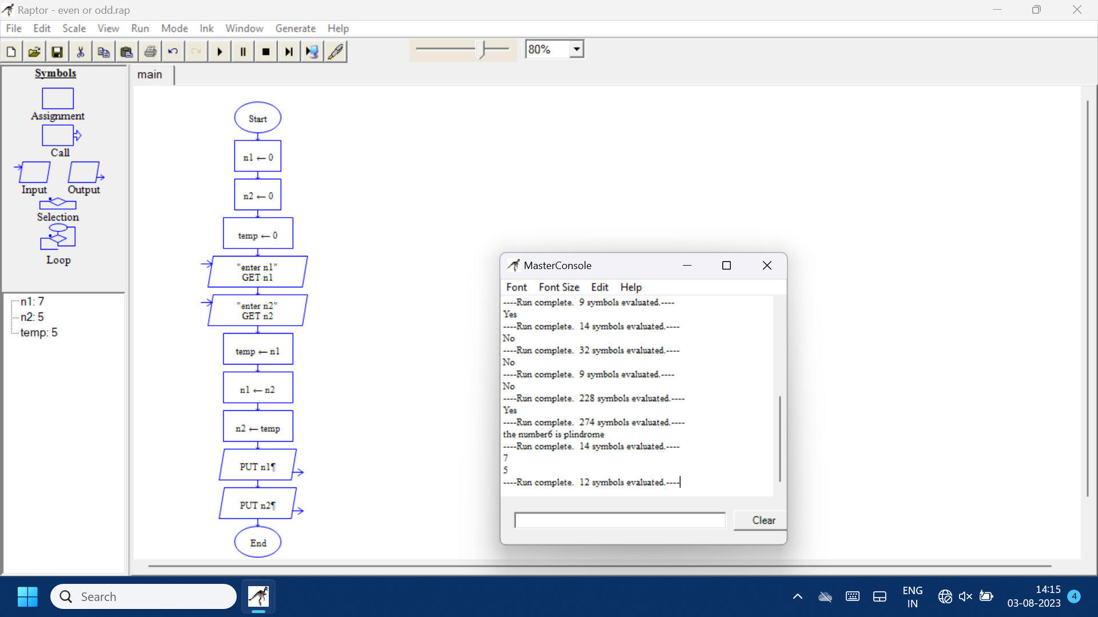

Draw And Validate Flowchart To Find Whether the Given Number Is Prime Or Not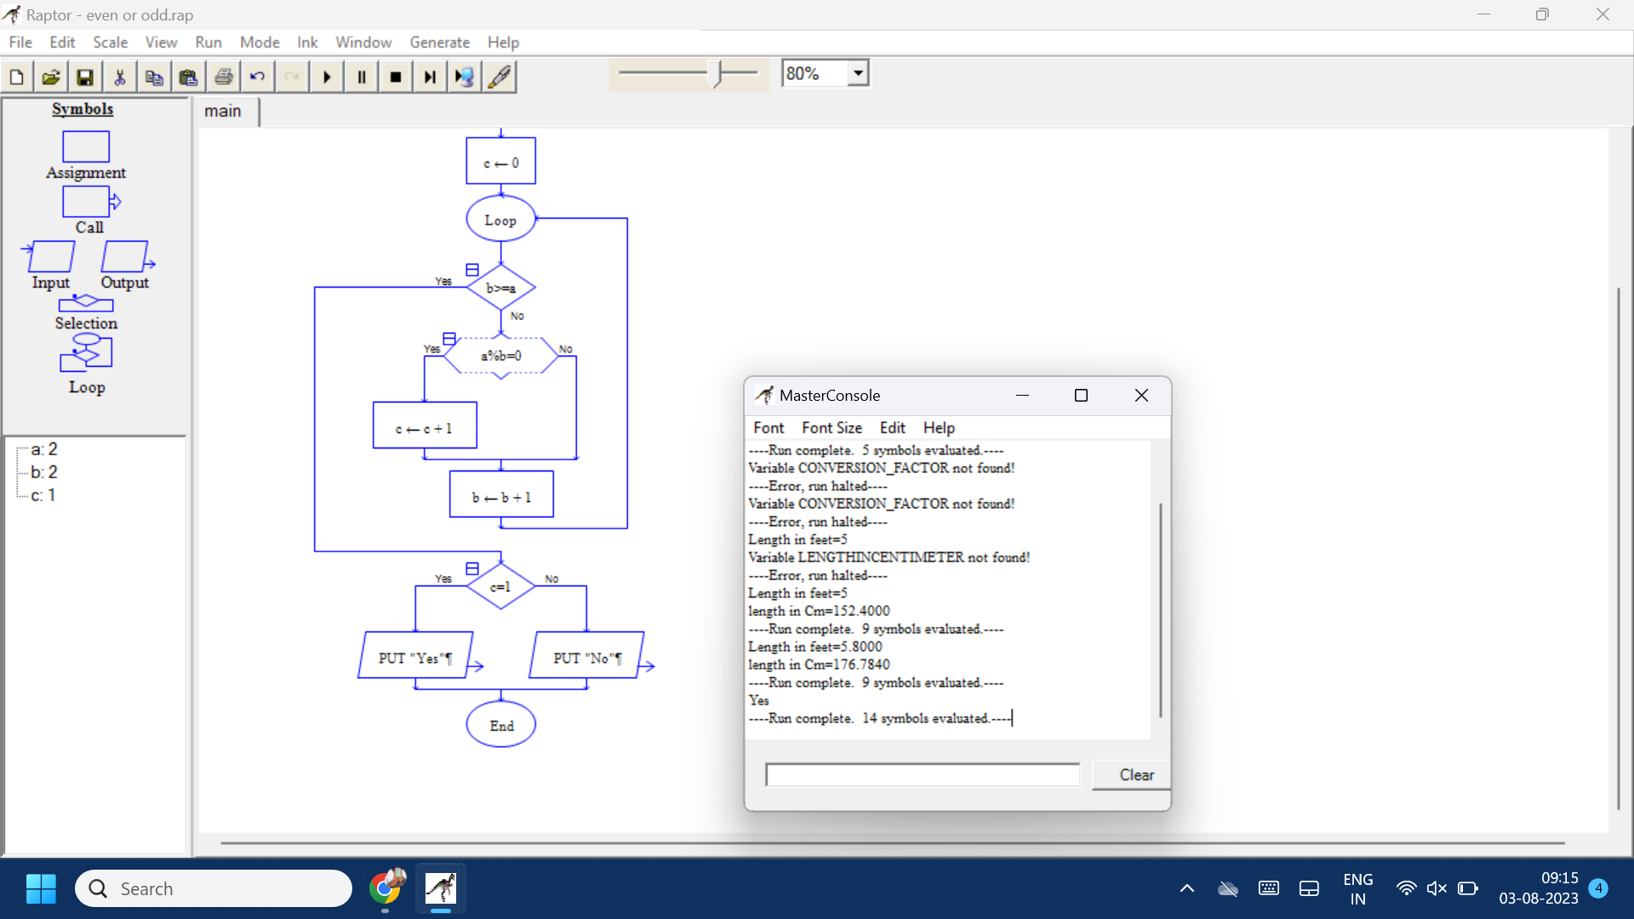Draw And

Draw and Validate Flowchart To Find Whether the Given Input Is Palindrome Or Not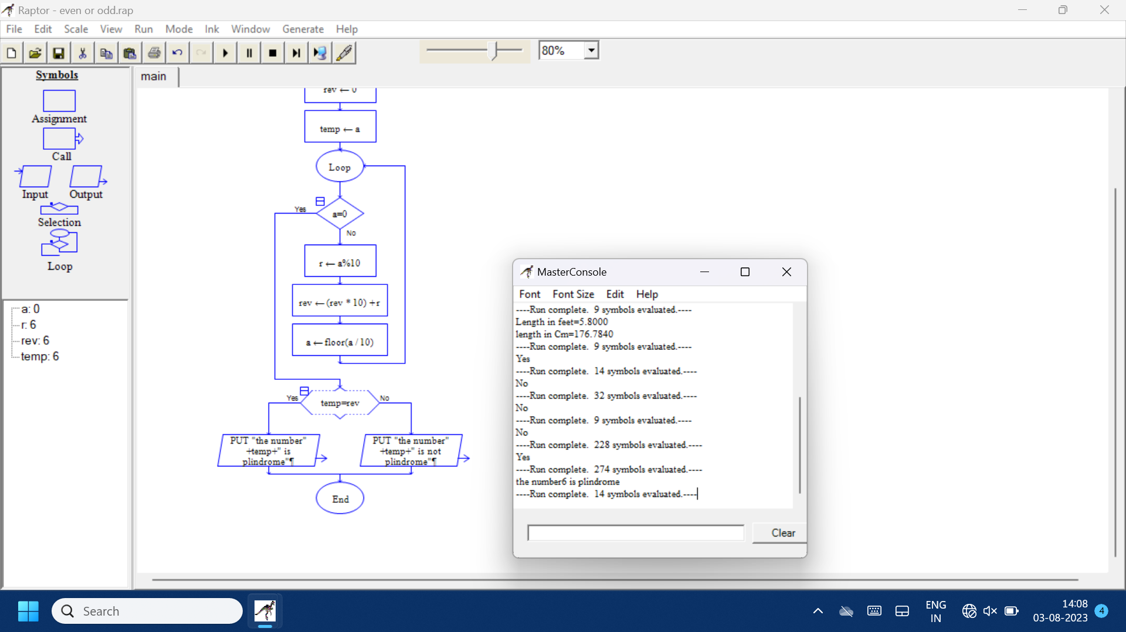Draw and validate flowchart to find sum two numbers 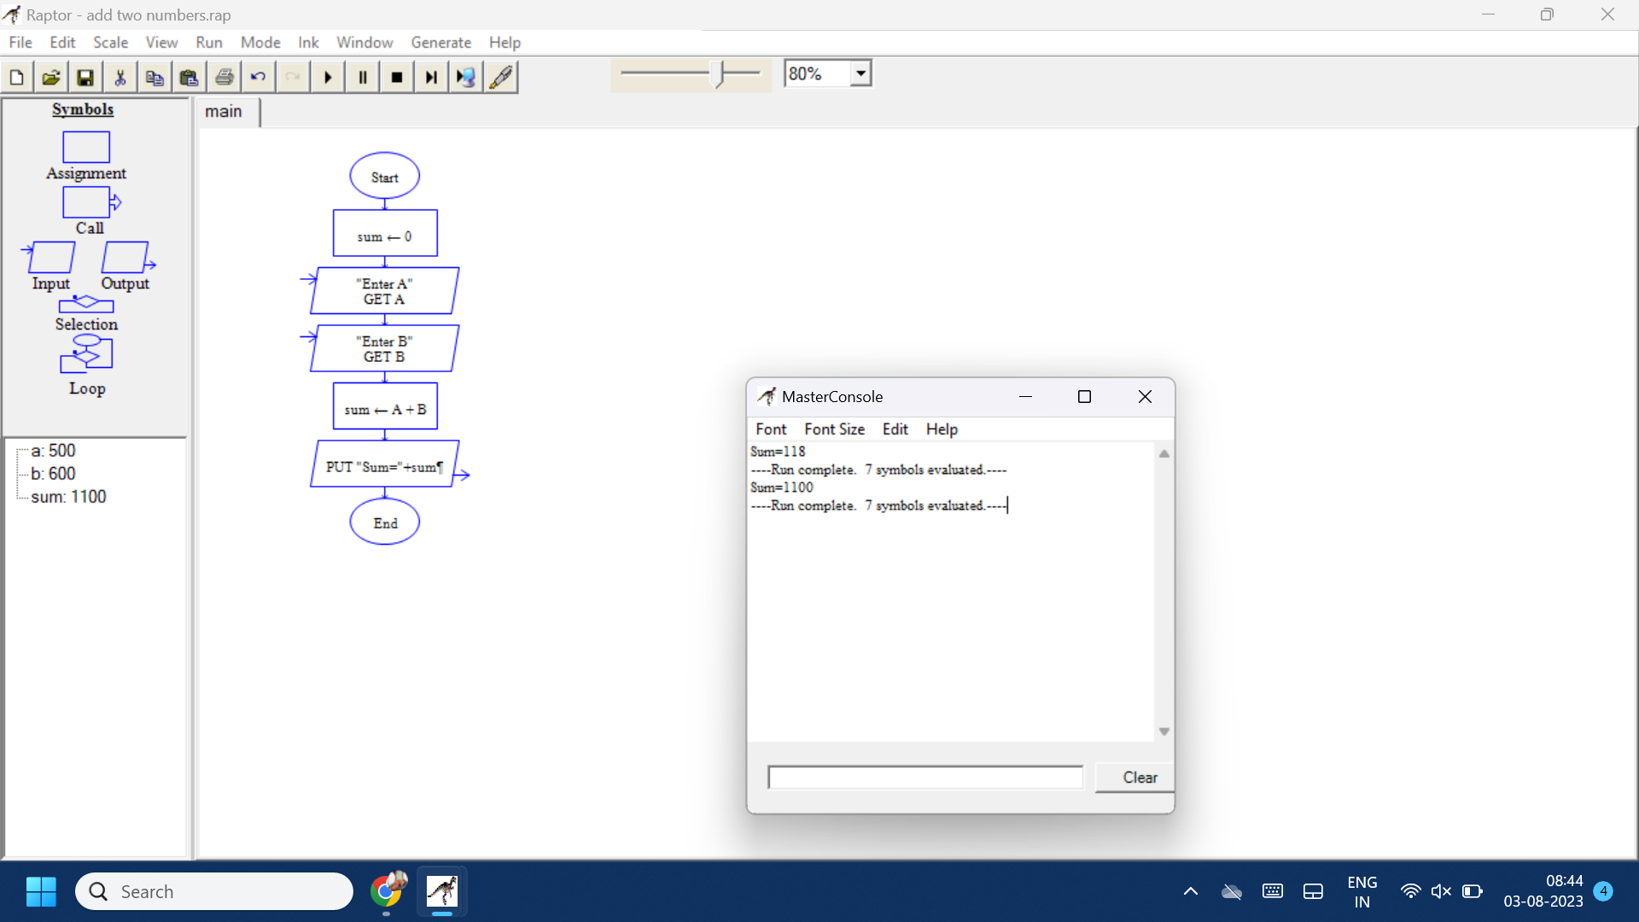Draw and validate flowchart to find Convert of feet to cm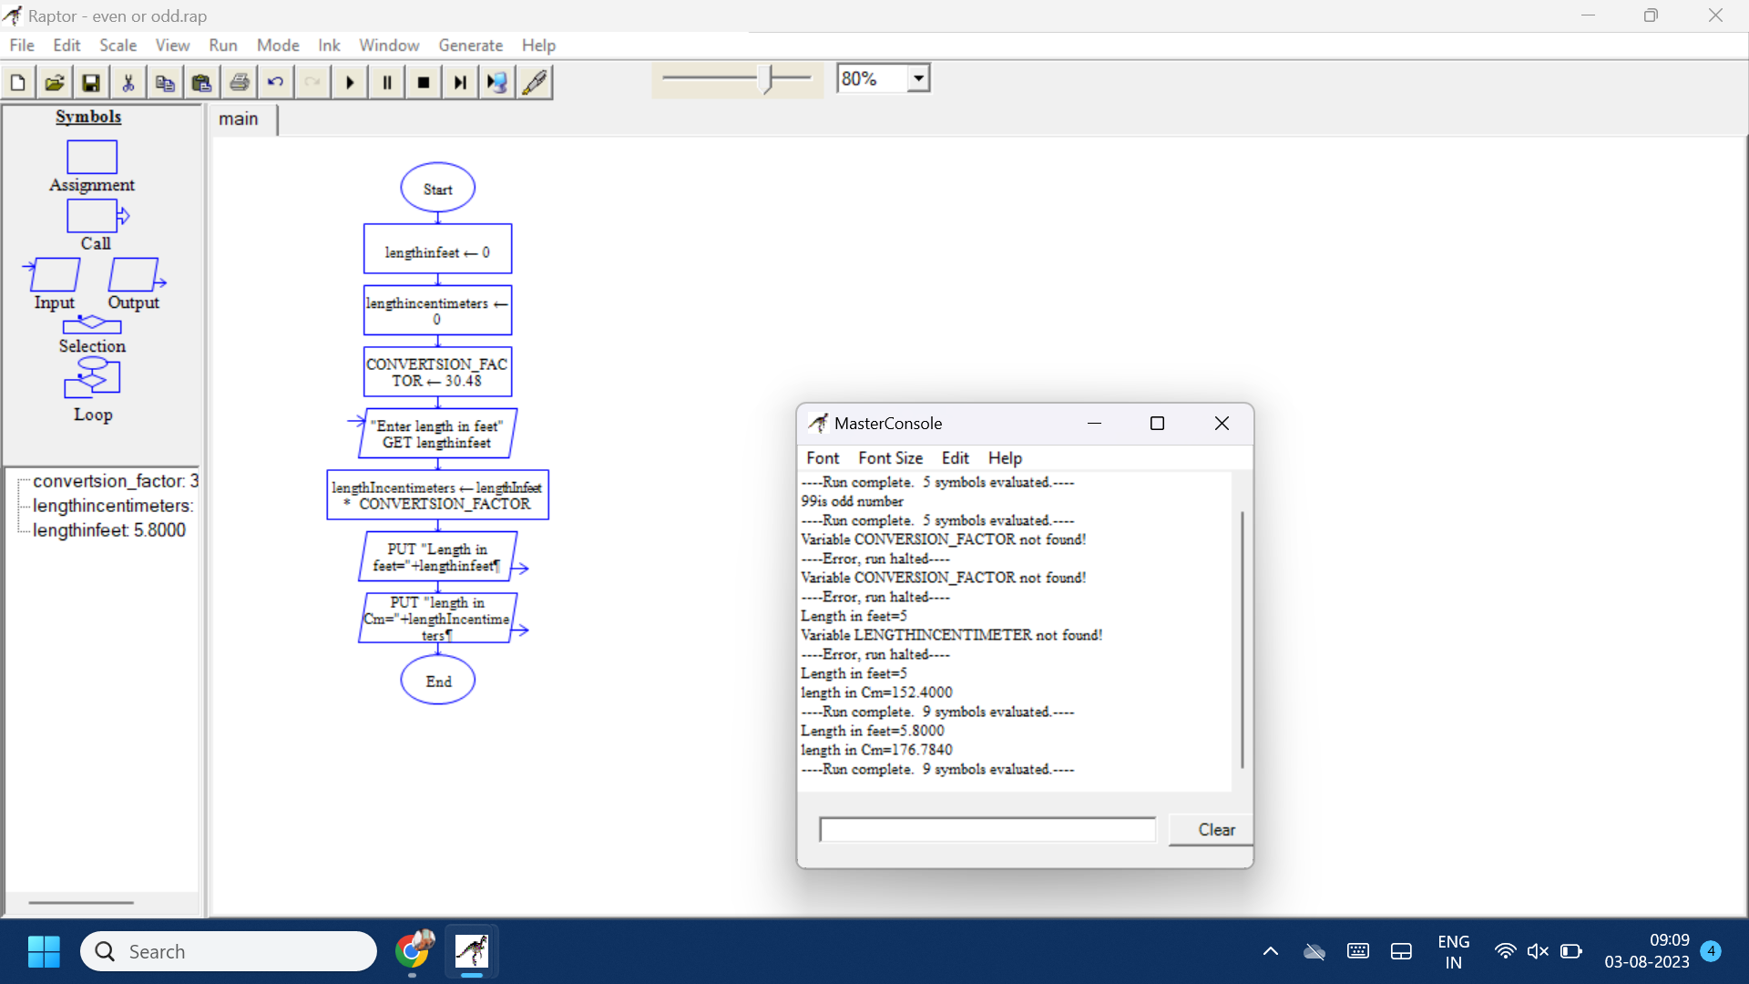Draw and validate flowchart to check the given number is odd or even